
ADC + GPIO + LEDs with FreeRTOS
Advanced Embedded Systems

Authors: Dr. Gilberto Ochoa Ruiz
Msc. Jorge German Perez Blanco
Contents
Introduction 3
Wiring instructions 3
Stage 1 Basic Concurrency (Polling and Global Variables) 3
Learning Objectives 3
What the Stage 1 Example Does 4
How to receive data through Serial Terminal 4
FreeRTOS Usage 7
Suggested Tests 7
Stage 2: Safe Data Exchange (Message Queues) 7
Learning Objectives 7
What the Stage 2 Example Does 8
FreeRTOS Usage 8
Suggested Tests 8
Annexes 8
Stage 1 Application code 8
Stage 2 Application code 12

Introduction
This example demonstrates the foundational integration of FreeRTOS with analog and digital peripherals on the NXP FRDM-KL25Z development board.
Designing a Real-Time Operating System application is an evolutionary process. To help you understand not just HOW to use RTOS features, but WHY they are necessary, this guide is divided into three distinct stages. You will start with a flawed but functional architecture, and progressively upgrade it by applying synchronization and hardware-management techniques.
Hardware Requirements and Setup
Before starting the code implementation, ensure you have the following components ready:
- 1x NXP FRDM-KL25Z Development Board
- 1x Breadboard
- 1x Push-button (Switch)
- 2x Potentiometers
- Jumper cables

Wiring instructions
- Connect the two potentiometers to pins `PTB1` (simulating a Light sensor) and `PTB2` (simulating a Temperature sensor).
- Connect the push-button to pin `PTB0` (ensure it uses 3.3V logic, don´t use 5V).
- The on-board RGB LED and UART0 are used natively by the board for output and console monitoring.
Future Improvements Note: For the scope of this baseline workshop, potentiometers are used to simulate analog inputs. In more advanced iterations, these should be replaced by actual hardware sensors, such as an LDR (Photoresistor) for luminosity and a digital DHT11 sensor for temperature and humidity.

Stage 1 Basic Concurrency (Polling and Global Variables)
This initial application intentionally employs basic software polling techniques and global variables to manage concurrency. While using global variables and polling in an RTOS is generally considered a structural anti-pattern, it serves as an excellent pedagogical baseline. In this stage, you will observe a functional system, understand task scheduling, and identify the exact bottlenecks—such as race conditions and wasted CPU cycles—that advanced mechanisms will solve in your subsequent iterations.

Learning Objectives
By completing this stage, you will be able to:
- Initialize and schedule multiple FreeRTOS tasks with different priorities.
- Configure and read the ADC16 module via software polling.
- Configure and read digital inputs (GPIO) using basic software debouncing.
- Identify firsthand the limitations, risks, and hardware collisions caused by polling and unprotected shared resources in concurrent environments.

What the Stage 1 Example Does
Actuation: Controls the on-board RGB LED based on predefined thresholds:
- If “Light” value < 2048, turns ON the Blue LED.
- If “Temperature value” > 2048, turns ON the Red LED.
- If the Button is pressed, turns ON the Green LED.
Serial Monitoring: Periodically prints the raw values to the UART console.

How to receive data through Serial Terminal
To receive data from the device, we will use the Terminal included in the MCUExpresso IDE.
To establish the serial communication with the board through the Terminal, click on the button highlighted in the figure, located in the bottom panel under the Terminal tab.
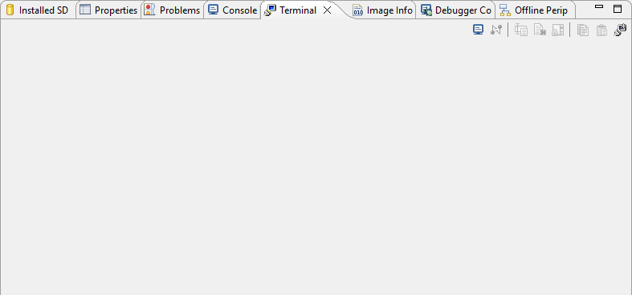
As a result, the terminal configuration window will appear, as shown in the following figure. Leave de default configuration as it matches the UART configuration done by code, just press the Ok button and the serial communication with the board will start.
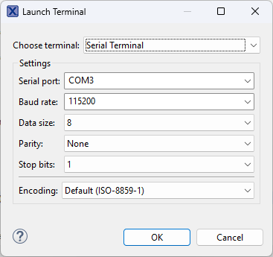
Now all data sent by the device through serial port should appear on the terminal.

How to configure Microcontrollers pins to match the desired function
The microcontroller features a vast array of peripherals but a limited number of physical pins. Consequently, the pin multiplexers must be configured to route the exact function required to each specific pin. For this particular setup, we need to configure two pins as ADC analog inputs to read the potentiometers, one pin as a digital input for the button, three pins as digital outputs to drive the LEDs, and the serial interface pins to establish communication with the board.
To access the pin configuration interface, click the button with the microcontroller symbol shown in the image. If this button does not appear on the toolbar, navigate to the “Window” menu, select “Perspective”, then “Open Perspective”, and finally, choose the “Pins” option.
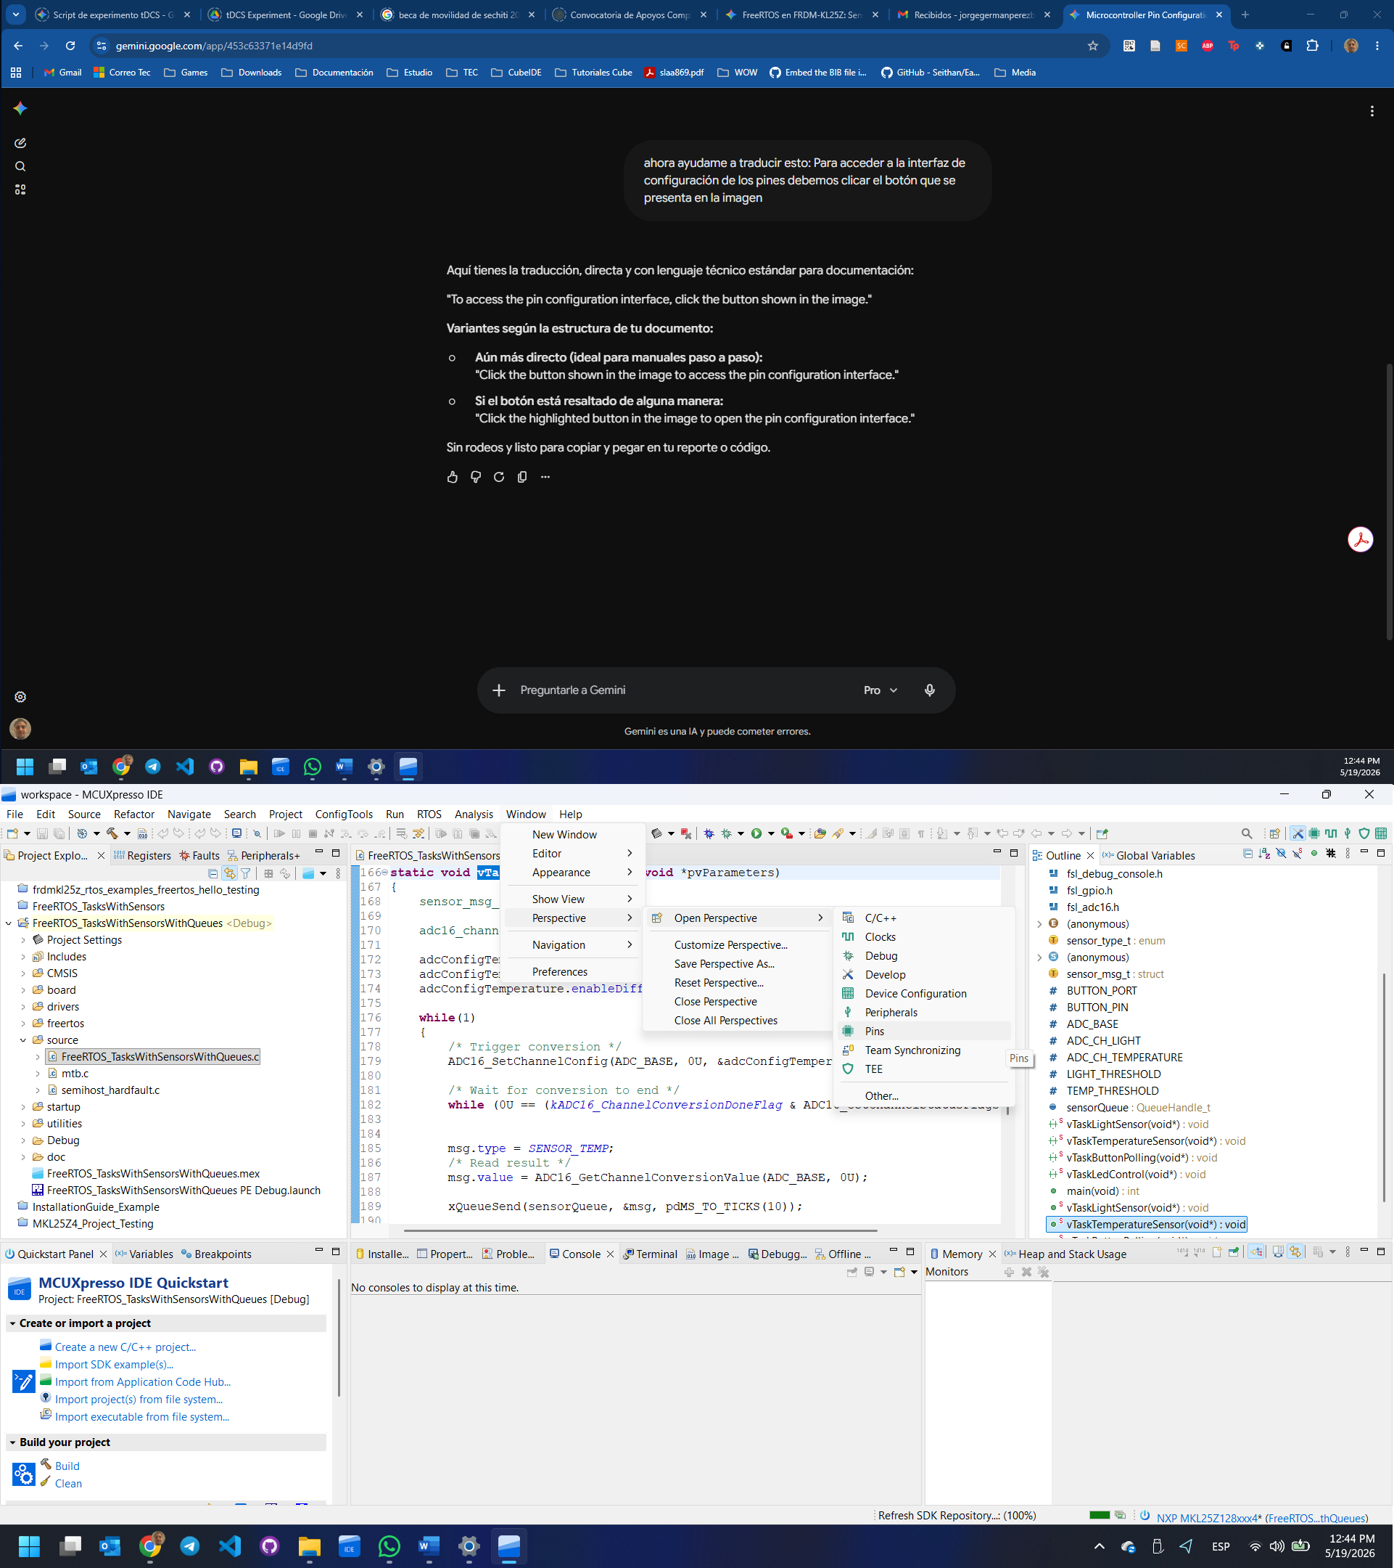
The pins associated with the red and green LEDs of the board are both connected to port B and to pins 18 and 19 respectively. So, we need to select then and configure their parameters (see picture below for details). You can start by writing the string “GPIOB 1” on the filter label as shown, and then select each pin with the right function. Make sure to click on the corresponding checkbox (red arrow) to enable the pin, as shown, once done, both pin cells should be green as the “GPIOB:GPIO,18” cell shown on the picture. There should also be an entry for each one on the bottom tab of the window, as shown for the “GPIOB, 18”. You should now be able to modify parameters for each pin in the bottom tab of the window.
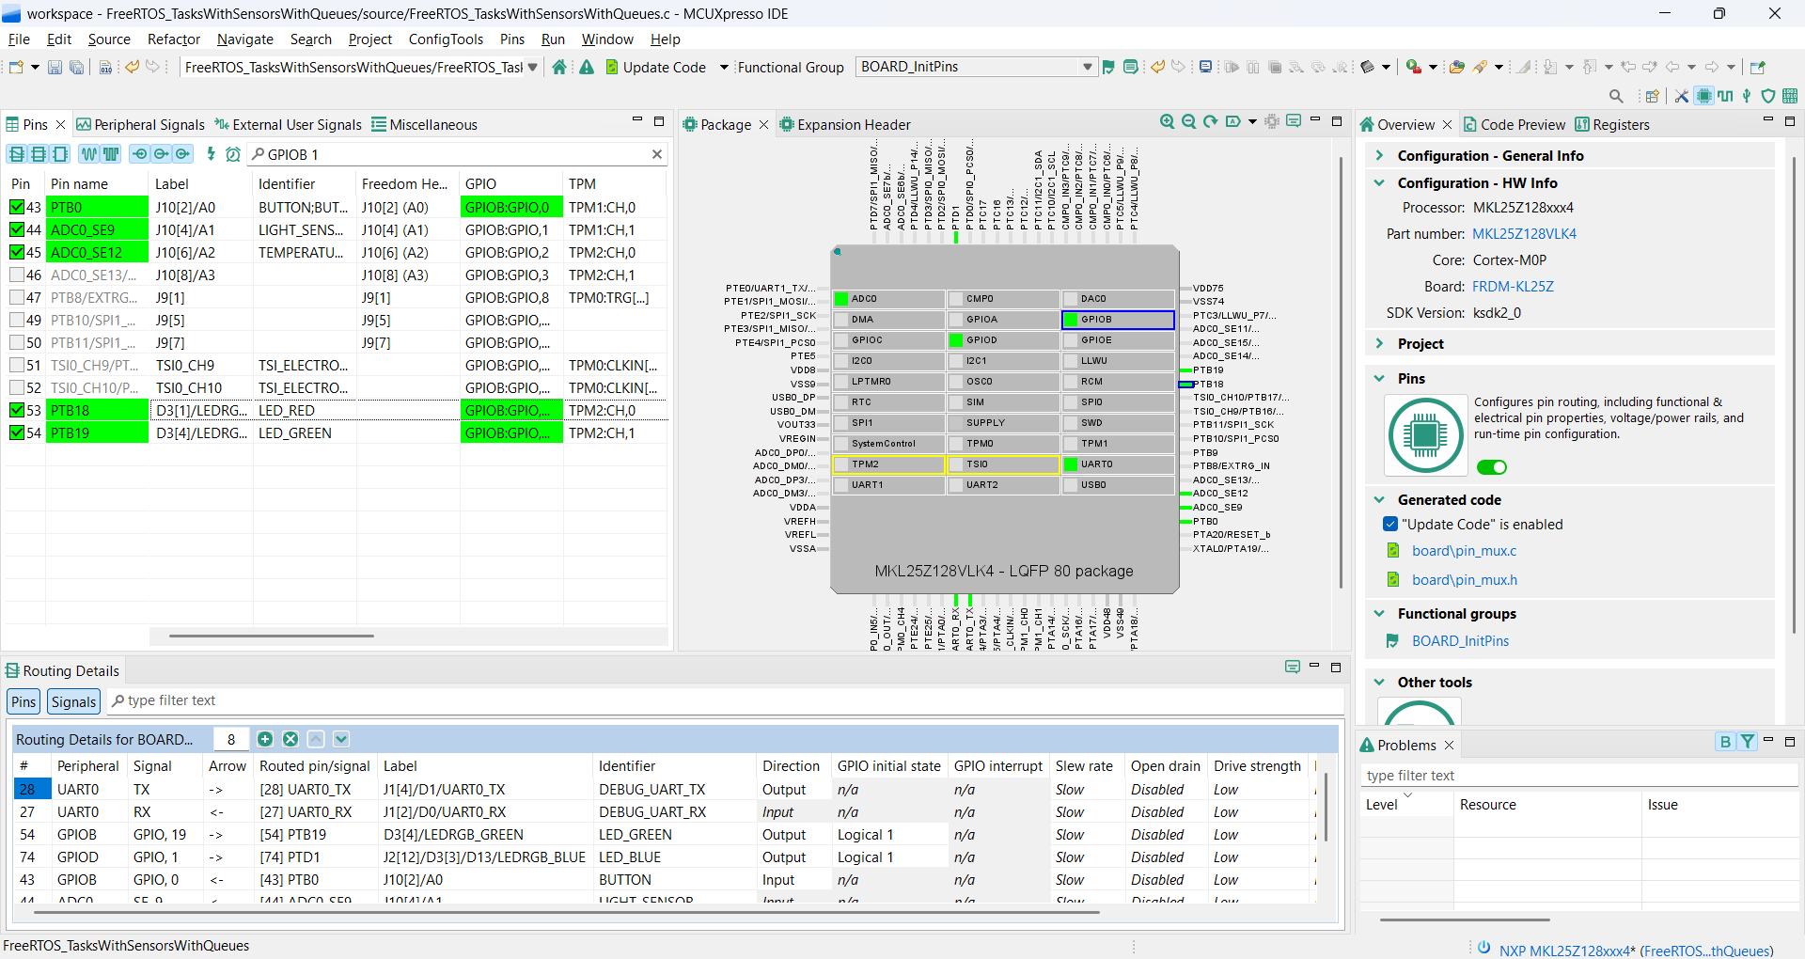

For pins with multiple functions, once the checkbox is enabled you should be prompted to select the corresponding function for the pin, in this case: GPIO. Select the function and click on “Done”.
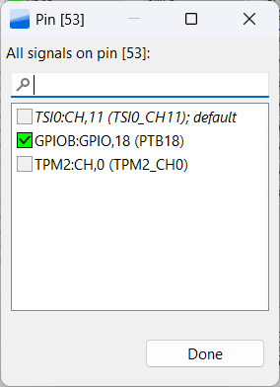

Now we are going to configure the parameters for both pins, as follows: “Direction” should be set to “Output” and “GPIO initial state” should be set to “Logical 1”, all other parameters should be left to their default state. Now to end the pin configuration and to export the initialization code to our project we need to hit the “Update Code” option located on the central region of the tools bar. All the configurations described are depicted in the next picture.


Finally, a confirmation prompt of the changes will pop up, you can review them and then click on the “OK” button.
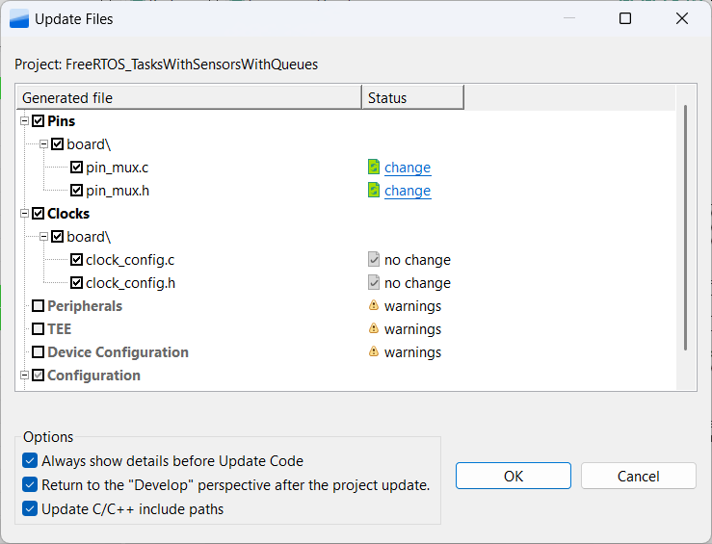

Following the steps above, apply the necessary configurations to all the pins required for the project.

FreeRTOS Usage
Tasks: Five independent tasks (vTaskLightSensor, vTaskTemperatureSensor, vTaskButtonPolling, vTaskLedControl, vTaskSerialMonitor) running at various periodic intervals using vTaskDelay.
Synchronization: None. This stage deliberately omits Queues, Semaphores, and Mutexes. Communication relies entirely on “volatile” global variables.

Suggested Tests
- Functional Test: Turn the potentiometers and observe the UART terminal. Verify the LEDs toggle correctly.
- Button Responsiveness: Press the button and observe the Green LED. Notice if there is any perceived delay or missed presses (a side-effect of polling, change 50ms just to see more notably the effect).
- The Inefficiency Trap (Global Variables): Look closely at vTaskLedControl. You programmed it to wake up every 200ms to evaluate “light_value” and “temp_value”. Now look at your sensor tasks: they only update that data every 500ms. You are forcing the CPU to wake up, evaluate stale data, and go back to sleep multiple times per second for absolutely no reason. This is a massive waste of processing power. Ask yourself: shouldn't the LED task just sleep indefinitely until new data actually arrives? (Hint: This structural flaw is exactly why you will implement Message Queues in Stage 2).

Stage 2: Safe Data Exchange (Message Queues)
In Stage 1, you learned why relying on global variables forces tasks into a vicious cycle of inefficient polling. Stage 2 fixes the memory sharing problem by introducing a Message Queue. By defining a standard message structure (sensor_msg_t), tasks can now package their data and send it directly to a unified queue. This completely shifts the paradigm of the consumer task (vTaskLedControl): instead of waking up blindly to check variables, it will now sleep indefinitely (portMAX_DELAY) consuming 0% CPU, waking up only when a new message actually arrives.

Learning Objectives
By completing this stage, you will be able to:
- Define custom structures (struct and enum) to standardize data packets.
- Create and manage a FreeRTOS Queue (xQueueCreate).
- Use xQueueSend to safely transmit data from producer tasks.
- Use xQueueReceive to efficiently block consumer tasks until data is available.

What the Stage 2 Example Does
The external behavior is nearly identical to Stage 1 (LEDs reacting to sensors), but the internal engine was reworked. Global variables have been removed. The serial monitor task has been temporarily disabled to focus purely on the Queue mechanics between the sensors and the LEDs.

FreeRTOS Usage
Tasks: Four tasks (vTaskLightSensor, vTaskTemperatureSensor, vTaskButtonPolling, vTaskLedControl).
Synchronization: A single sensorQueue capable of holding 10 messages of type sensor_msg_t.

Suggested Tests
- The Efficiency Verification: Review the vTaskLedControl code. Notice “xQueueReceive(sensorQueue, &msg, portMAX_DELAY)”. The task is no longer wasting CPU cycles; it yields complete control to the RTOS until a producer sends a message.
- The Hardware Collision Trap (Missing Mutex): We fixed the memory, but did we fix the hardware? Look at vTaskLightSensor and vTaskTemperatureSensor. Both tasks are still writing to the `ADC0` hardware registers (`ADC16_SetChannelConfig`) simultaneously. Because they have the same priority, the scheduler can interrupt one to run the other midway through a conversion. You will eventually read garbage data. Hardware peripherals are shared resources too. (Hint: This is why you will need a Mutex in Stage 3).
- The Button Polling Reality: vTaskButtonPolling is still using a 50ms delay loop to ask the hardware if the button was pressed. While the data transfer is now safe, the detection method is still primitive. Stage 3 will fix this using Hardware Interrupts (ISR).

Annexes

Stage 1 Application code
*
* main.c - FreeRTOS KL25Z
* Example: tasks with sensors without queues or interruptions
*/

#include <stdio.h>
#include <stdint.h>
#include <stdbool.h>

#include "FreeRTOS.h"
#include "task.h"

#include "board.h"
#include "pin_mux.h"
#include "clock_config.h"
#include "fsl_debug_console.h"
#include "fsl_gpio.h"
#include "fsl_adc16.h"

/* =========================
* Global Variables
* ========================= */

volatile uint16_t light_value = 0;
volatile uint16_t temp_value = 0;
volatile uint8_t button_state = 0;

#define BUTTON_PORT GPIOB
#define BUTTON_PIN 0U /* Assigned to PTB0 (J10 - pin 2 on the board)*/
#define ADC_BASE ADC0
#define ADC_CH_LIGHT 9U /* Assigned to PTB1 (J10 - pin 4 on the board)*/
#define ADC_CH_TEMPERATURE 12U /* Assigned to PTB2 (J10 - pin 6 on the board)*/

/* Example thresholds */
#define LIGHT_THRESHOLD 2048
#define TEMP_THRESHOLD 2048

/* =========================
* Prototypes
* ========================= */

static void vTaskLightSensor(void *pvParameters);
static void vTaskTemperatureSensor(void *pvParameters);
static void vTaskButtonPolling(void *pvParameters);
static void vTaskLedControl(void *pvParameters);
static void vTaskSerialMonitor(void *pvParameters);

/* =========================
* Main
* ========================= */

int main(void)
{
BOARD_InitBootPins();
BOARD_InitBootClocks();
BOARD_InitDebugConsole();

//ADC CONFIG
/*ADC0 Module Global Configuration */
adc16_config_t adc16ConfigStruct;
ADC16_GetDefaultConfig(&adc16ConfigStruct);
adc16ConfigStruct.resolution = kADC16_ResolutionSE12Bit;
/* Continuous conversion turned off, to control it from the RTOS */
adc16ConfigStruct.enableContinuousConversion = false;
ADC16_Init(ADC_BASE, &adc16ConfigStruct);
ADC16_EnableHardwareTrigger(ADC_BASE, false);

ADC16_DoAutoCalibration(ADC_BASE);

PRINTF("FreeRTOS KL25Z - Tasks with sensors without queues or interruptions\r\n");

xTaskCreate(vTaskLightSensor,
"Light",
configMINIMAL_STACK_SIZE + 100,
NULL,
2,
NULL);

xTaskCreate(vTaskTemperatureSensor,
"Temp",
configMINIMAL_STACK_SIZE + 100,
NULL,
2,
NULL);

xTaskCreate(vTaskButtonPolling,
"Button",
configMINIMAL_STACK_SIZE + 100,
NULL,
1,
NULL);

xTaskCreate(vTaskLedControl,
"LEDs",
configMINIMAL_STACK_SIZE + 100,
NULL,
3,
NULL);

xTaskCreate(vTaskSerialMonitor,
"Serial",
configMINIMAL_STACK_SIZE + 200,
NULL,
1,
NULL);

vTaskStartScheduler();

while(1)
{
}
}

/* =========================
* Tasks
* ========================= */

static void vTaskLightSensor(void *pvParameters)
{
adc16_channel_config_t adcConfigLight;

adcConfigLight.channelNumber = ADC_CH_LIGHT;
adcConfigLight.enableInterruptOnConversionCompleted = false;
adcConfigLight.enableDifferentialConversion = false;

while(1)
{
/* Trigger conversion */
ADC16_SetChannelConfig(ADC_BASE, 0U, &adcConfigLight);

/* Wait for conversion to end */
while (0U == (kADC16_ChannelConversionDoneFlag & ADC16_GetChannelStatusFlags(ADC_BASE, 0U))) {}

/* Read result */
light_value = ADC16_GetChannelConversionValue(ADC_BASE, 0U);
vTaskDelay(pdMS_TO_TICKS(500));
}
}

static void vTaskTemperatureSensor(void *pvParameters)
{
adc16_channel_config_t adcConfigTemperature;

adcConfigTemperature.channelNumber = ADC_CH_TEMPERATURE;
adcConfigTemperature.enableInterruptOnConversionCompleted = false;
adcConfigTemperature.enableDifferentialConversion = false;

while(1)
{
/* Trigger conversion */
ADC16_SetChannelConfig(ADC_BASE, 0U, &adcConfigTemperature);

/* Wait for conversion to end */
while (0U == (kADC16_ChannelConversionDoneFlag & ADC16_GetChannelStatusFlags(ADC_BASE, 0U))) {}

/* Read result */
temp_value = ADC16_GetChannelConversionValue(ADC_BASE, 0U);
vTaskDelay(pdMS_TO_TICKS(500));
}
}

static void vTaskButtonPolling(void *pvParameters)
{
uint32_t last_state = 1; /* Physical or internal Pull-Up configuration assumed */

for (;;) {
button_state = GPIO_ReadPinInput(BUTTON_PORT, BUTTON_PIN);

/* Falling edge detection */
if (button_state == 0 && last_state == 1) {
// PRINTF("Event: Button pressed.\r\n");
}
last_state = button_state;

/* 50ms blocking. Acts as a button debounce */
vTaskDelay(pdMS_TO_TICKS(50));
}
}

static void vTaskLedControl(void *pvParameters)
{
while(1)
{
if(light_value < LIGHT_THRESHOLD)
{
LED_BLUE_ON();
}
else
{
LED_BLUE_OFF();
}

if(temp_value > TEMP_THRESHOLD)
{
LED_RED_ON();
}
else
{
LED_RED_OFF();
}

if(!button_state)
{
LED_GREEN_ON();
}
else
{
LED_GREEN_OFF();
}

vTaskDelay(pdMS_TO_TICKS(200));
}
}

static void vTaskSerialMonitor(void *pvParameters)
{
while(1)
{
PRINTF("Light: %u | Temp: %u | Button: %u\r\n",
light_value,
temp_value,
button_state);

vTaskDelay(pdMS_TO_TICKS(1500));
}
}

Stage 2 Application code

/*
* main.c - FreeRTOS KL25Z
* Example: tasks with sensors without queues or interruptions
*/

#include <stdio.h>
#include <stdint.h>
#include <stdbool.h>

#include "FreeRTOS.h"
#include "task.h"
#include "queue.h"

#include "board.h"
#include "pin_mux.h"
#include "clock_config.h"
#include "fsl_debug_console.h"
#include "fsl_gpio.h"
#include "fsl_adc16.h"

/* =========================
* Global Variables
* ========================= */

typedef enum
{
SENSOR_LIGHT,
SENSOR_TEMP,
SENSOR_BUTTON
} sensor_type_t;

typedef struct
{
sensor_type_t type;
uint16_t value;
} sensor_msg_t;

//volatile uint16_t light_value = 0;
//volatile uint16_t temp_value = 0;
//volatile uint8_t button_state = 0;

#define BUTTON_PORT GPIOB
#define BUTTON_PIN 0U /* Assigned to PTB0 (J10 - pin 2 on the board)*/
#define ADC_BASE ADC0
#define ADC_CH_LIGHT 9U /* Assigned to PTB1 (J10 - pin 4 on the board)*/
#define ADC_CH_TEMPERATURE 12U /* Assigned to PTB2 (J10 - pin 6 on the board)*/

/* Example thresholds */
#define LIGHT_THRESHOLD 2048
#define TEMP_THRESHOLD 2048

QueueHandle_t sensorQueue;

/* =========================
* Prototypes
* ========================= */

static void vTaskLightSensor(void *pvParameters);
static void vTaskTemperatureSensor(void *pvParameters);
static void vTaskButtonPolling(void *pvParameters);
static void vTaskLedControl(void *pvParameters);

/* =========================
* Main
* ========================= */

int main(void)
{
BOARD_InitBootPins();
BOARD_InitBootClocks();
BOARD_InitDebugConsole();

//ADC CONFIG
/*ADC0 Module Global Configuration */
adc16_config_t adc16ConfigStruct;
ADC16_GetDefaultConfig(&adc16ConfigStruct);
adc16ConfigStruct.resolution = kADC16_ResolutionSE12Bit;
/* Continuous conversion turned off, to control it from the RTOS */
adc16ConfigStruct.enableContinuousConversion = false;
ADC16_Init(ADC_BASE, &adc16ConfigStruct);
ADC16_EnableHardwareTrigger(ADC_BASE, false);

ADC16_DoAutoCalibration(ADC_BASE);

sensorQueue = xQueueCreate(10, sizeof(sensor_msg_t));

if(sensorQueue == NULL)
{
PRINTF("Error creating queue\r\n");
while(1);
}

PRINTF("FreeRTOS KL25Z - Tasks with sensors without queues or interruptions\r\n");

xTaskCreate(vTaskLightSensor,
"Light",
configMINIMAL_STACK_SIZE + 100,
NULL,
2,
NULL);

xTaskCreate(vTaskTemperatureSensor,
"Temp",
configMINIMAL_STACK_SIZE + 100,
NULL,
2,
NULL);

xTaskCreate(vTaskButtonPolling,
"Button",
configMINIMAL_STACK_SIZE + 100,
NULL,
1,
NULL);

xTaskCreate(vTaskLedControl,
"LEDs",
configMINIMAL_STACK_SIZE + 100,
NULL,
3,
NULL);

vTaskStartScheduler();

while(1)
{
}
}

/* =========================
* Tasks
* ========================= */

static void vTaskLightSensor(void *pvParameters)
{
sensor_msg_t msg;

adc16_channel_config_t adcConfigLight;

adcConfigLight.channelNumber = ADC_CH_LIGHT;
adcConfigLight.enableInterruptOnConversionCompleted = false;
adcConfigLight.enableDifferentialConversion = false;

while(1)
{
/* Trigger conversion */
ADC16_SetChannelConfig(ADC_BASE, 0U, &adcConfigLight);

/* Wait for conversion to end */
while (0U == (kADC16_ChannelConversionDoneFlag & ADC16_GetChannelStatusFlags(ADC_BASE, 0U))) {}

msg.type = SENSOR_LIGHT;
/* Read result */
msg.value = ADC16_GetChannelConversionValue(ADC_BASE, 0U);;

xQueueSend(sensorQueue, &msg, pdMS_TO_TICKS(10));

vTaskDelay(pdMS_TO_TICKS(500));
}
}

static void vTaskTemperatureSensor(void *pvParameters)
{
sensor_msg_t msg;

adc16_channel_config_t adcConfigTemperature;

adcConfigTemperature.channelNumber = ADC_CH_TEMPERATURE;
adcConfigTemperature.enableInterruptOnConversionCompleted = false;
adcConfigTemperature.enableDifferentialConversion = false;

while(1)
{
/* Trigger conversion */
ADC16_SetChannelConfig(ADC_BASE, 0U, &adcConfigTemperature);

/* Wait for conversion to end */
while (0U == (kADC16_ChannelConversionDoneFlag & ADC16_GetChannelStatusFlags(ADC_BASE, 0U))) {}

msg.type = SENSOR_TEMP;
/* Read result */
msg.value = ADC16_GetChannelConversionValue(ADC_BASE, 0U);

xQueueSend(sensorQueue, &msg, pdMS_TO_TICKS(10));

vTaskDelay(pdMS_TO_TICKS(500));
}
}

static void vTaskButtonPolling(void *pvParameters)
{
sensor_msg_t msg;

uint32_t button_state = 1; /* Physical or internal Pull-Up configuration assumed */
uint32_t last_state = 1;

for (;;) {
button_state = GPIO_ReadPinInput(BUTTON_PORT, BUTTON_PIN);

/* Falling edge detection */
if (button_state == 0 && last_state == 1) {
// PRINTF("Event: Button pressed.\r\n");
last_state = button_state;
}

msg.type = SENSOR_BUTTON;
msg.value = button_state;

xQueueSend(sensorQueue, &msg, pdMS_TO_TICKS(10));

/* 50ms blocking. Acts as a button debounce */
vTaskDelay(pdMS_TO_TICKS(50));
}
}

static void vTaskLedControl(void *pvParameters)
{
sensor_msg_t msg;

uint16_t light_value = 0;
uint16_t temp_value = 0;
uint16_t button_value = 0;

while(1)
{
if(xQueueReceive(sensorQueue, &msg, portMAX_DELAY) == pdPASS)
{
switch(msg.type)
{
case SENSOR_LIGHT:
light_value = msg.value;
break;

case SENSOR_TEMP:
temp_value = msg.value;
break;

case SENSOR_BUTTON:
button_value = msg.value;
break;
}

if(light_value < LIGHT_THRESHOLD)
LED_BLUE_ON();
else
LED_BLUE_OFF();

if(temp_value > TEMP_THRESHOLD)
LED_RED_ON();
else
LED_RED_OFF();

if(button_value)
LED_GREEN_ON();
else
LED_GREEN_OFF();
}
}
}

